ANNUAL PRODUCT QUALITY REVIEW
(PARTY NAME )

APR No. APQR/PRODUCT NAME /YYYY

PRODUCT:

PERIOD: “ - ”

___________
Prepared by: Sign & Date:

___________
Reviewed by: Sign & Date:

___________
Approved by: Sign & Date:

Criteria for Study:
- Product Details.
- Number of Batches manufactured.
- A review of marketing Authorization variations submitted/ granted / refused, including those for third country (export only) dossiers.
- A review of starting materials including packaging materials used in the product, especially those from new sources.(Master Document References )
- Active Pharmaceutical Ingredients (API) critical parameters analytical data with trend graphs including their vendor details.
- Environment Control Result During Mixing and their trend graph.
- Water Testing Result and their trend graph.(Physico Chemical / microbiological Analysis)
- Bulk Analysis Test and their trend graph.
- Bio burden Test Result and their trend graph.
- Filter Integrity Test and their trend graph.
- Yield of all critical stages and their trend graph.
- Final Batch Yield at the end of all critical stages & Analysis report with trend graph.
- A review of all batches that failed to meet established specification(s) and their investigation.
- A review of all changes carried out to the processes or analytical methods.
- Out of specifications and laboratory Investigations:
- Process Validation Status:
- Review of Deviation.
- A review of all quality –related returns, complaints and recalls and the investigations performed at the time.
- Control Sample Review.
- A review of previous APQRs of the product and review of any identified delays in CAPAs or incidence.
- A review of the results of the stability monitoring programme and any adverse trends.
- The qualification status of relevant equipment and utilities, e.g. HVAC, Water etc.
- A review of Product Sterilization parameters (duration of process, temperature and pressure
- A review of any contractual arrangements to ensure that they are up to date.
- Annual Product Report – Summary

- Product Details:
 | Product |  |  | :
 | Dosage Form |  |  | :
 | Label Claim |  |  | :
 | Shelf Life |  |  | :
 | Category |  |  | :
Minimum Batch size :
Maximum Batch size :

 | Master Formula Ref No. | Generic Name | Brand Name
Pack Details
:

- Number of Batches manufactured:
Month | Batch No. | Mfg. Date | Exp. Date | Pack Size | Batch Size
Jan
Feb
Mar
Apr
May
Jun
July
Aug
Sep
Oct
Nov
Dec
Total no. of Batches

- A review of marketing Authorization variations submitted/ granted / refused, including those
for third country (export only) dossiers.
- A review of starting materials including packaging materials used in the product, especially
those from new sources. (Master Document References)
Batch Manufacturing Record :
Batch Packing Record :
Details of Primary Packing Material :
Used in  Batches | Material Name | Supplier Name | Q. C. No.

- Active Pharmaceutical Ingredients (API) critical parameters analytical data with trend graphs including their vendor details:
AR Nos. | Used in Batches | Description | Vendor Details | Critical Parameters
 |  |  |  | Loss on drying  alert limit-  action limit- | Sulphated ash  alert limit-  action limit- | Assay  alert limit-  action limit-

- 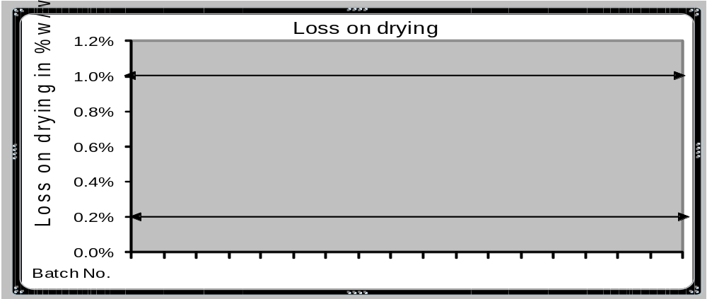LOD:

Comments:

- Sulphated ash:
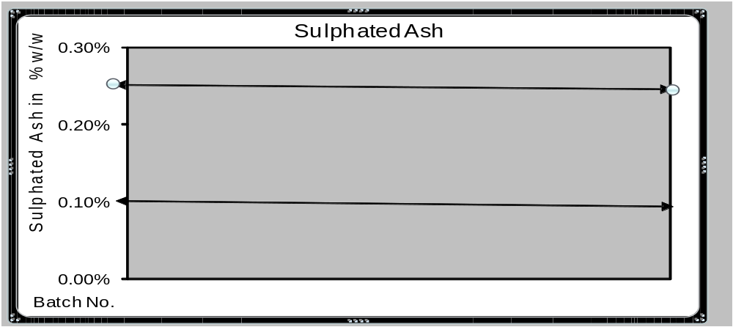
Comments:

c. Assay:
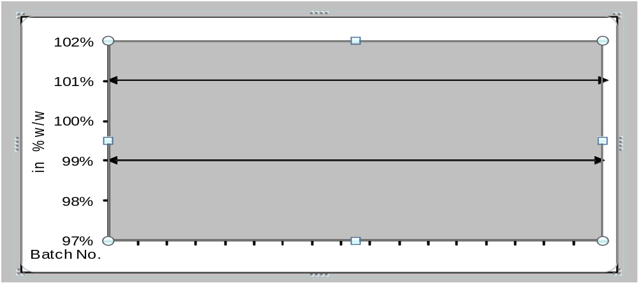
Comments:

- Environment Control Result During Mixing :
Batch Number | Temperature  (Limit:27 +-2℃) | Differential Pressure  (Limit:15 +-16 Pascal) | Relative Humidity  (Limit 50% - 60%)
- Temperature :
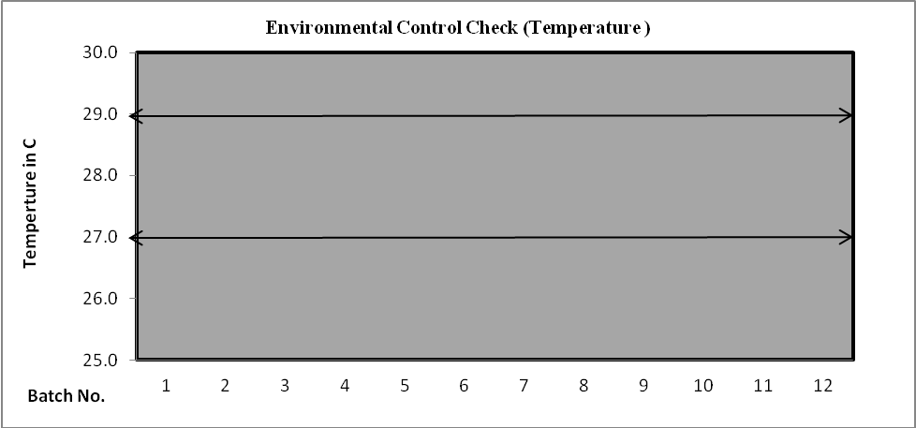
Comments:

- Differential Pressure
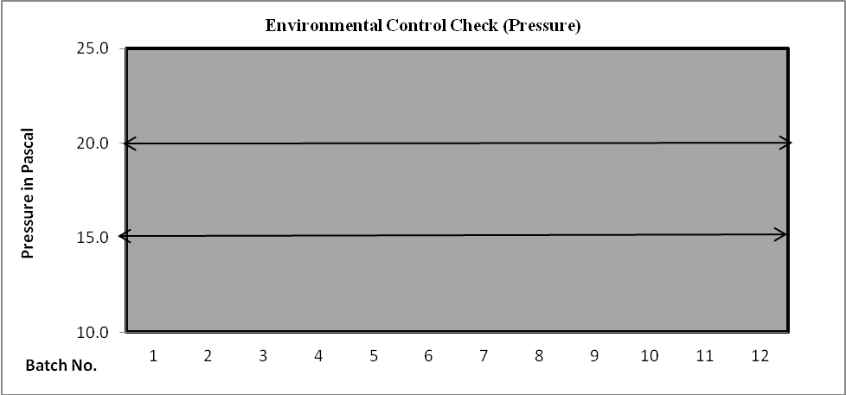
Comments:

- Relative Humidity
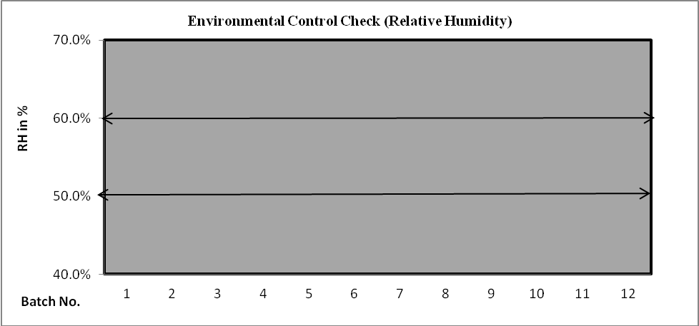

Comments:

- Water Testing Result (Physico Chemical / microbiological Analysis):
Batch Number | Description | pH (Limit:5-7)
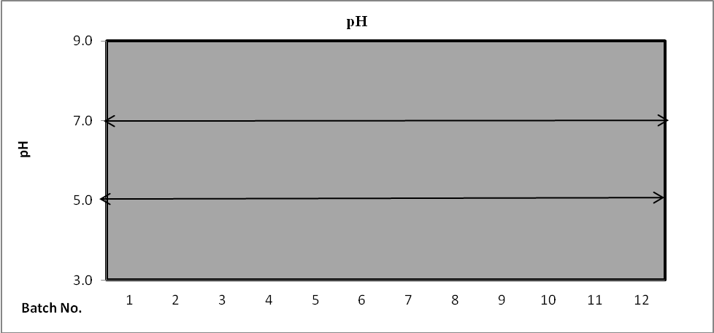

Comments:

- Bulk Testing Test:
Batch Number | Description  (Clear colorless Solution) | pH  (Limit 4.5 to 6.0) | Assay  (Limit-)
- pH

Comments:

- Assay
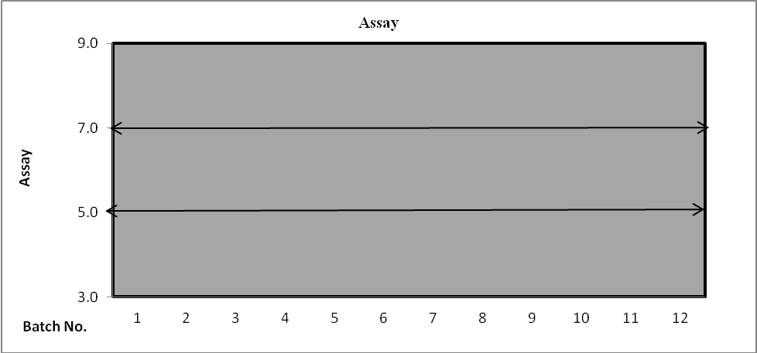

Comments:

- Bio burden Test Result
Batch Number | Bio burden  (Limit- 100cfu/100ml)

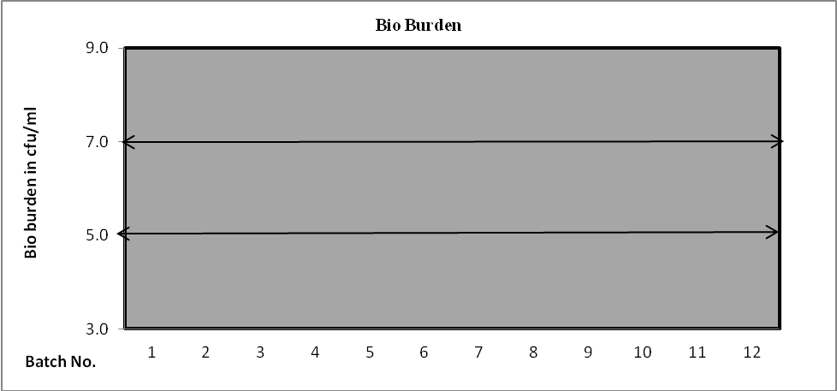

Comments:

- Filter Integrity test:
Batch No. | BPT pre Mixing | BPT post Mixing | BPT pre holding | BPT post holding | BPT pre FFS M/C | BPT post FFS M/C

- Bubble Point Test Pre Mixing:
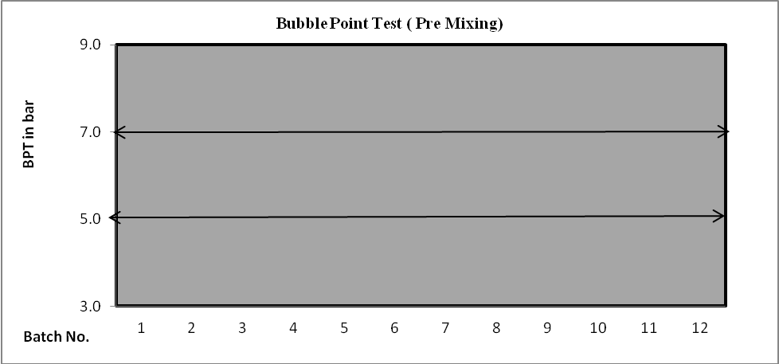

Comments:

- Bubble Point Test Post Mixing:
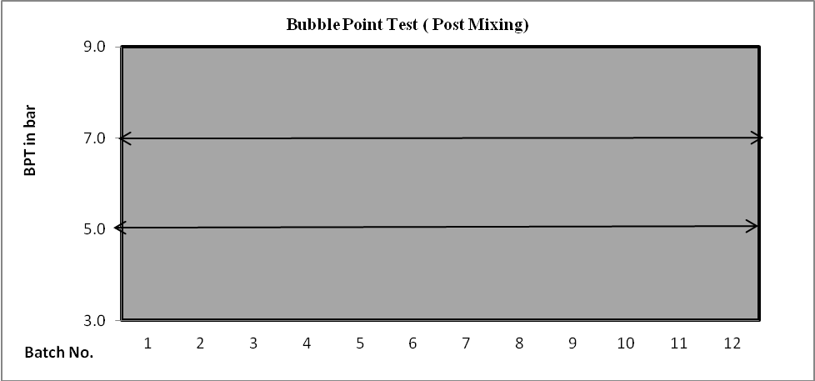

Comments:

- Bubble Point Test Pre Holding:
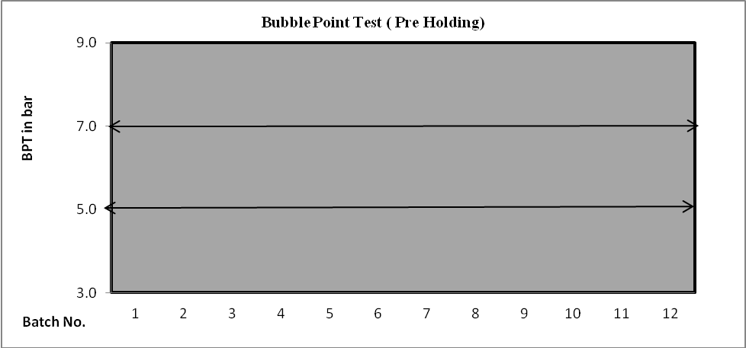

Comments:

- Bubble Point Test Post Holding:
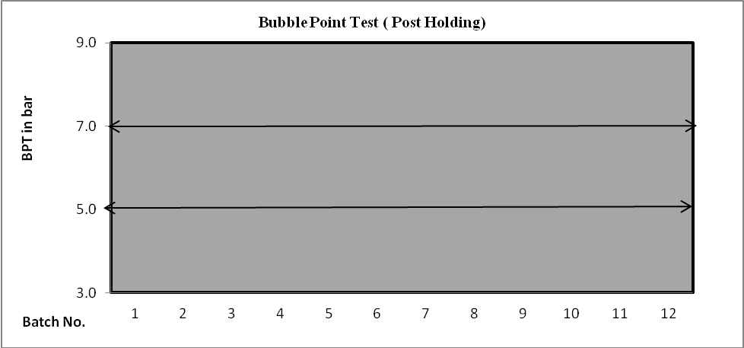

Comments:

- Bubble Point Test Pre FFS:
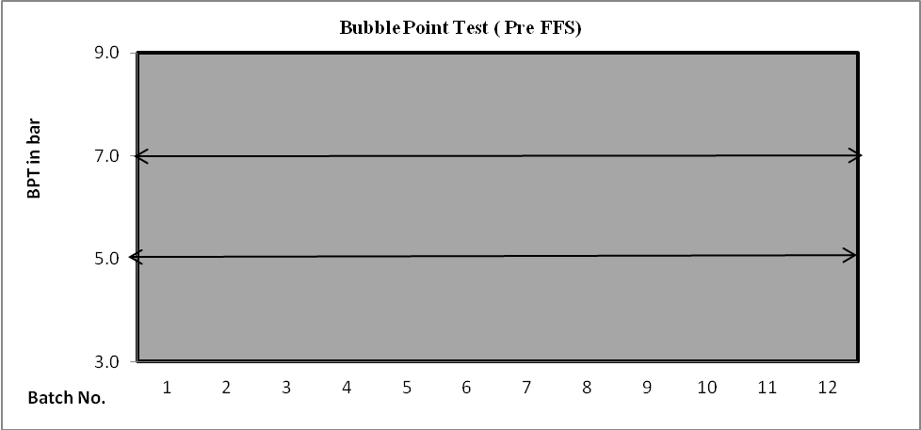

Comments:

- Bubble Point Test PostFFS:
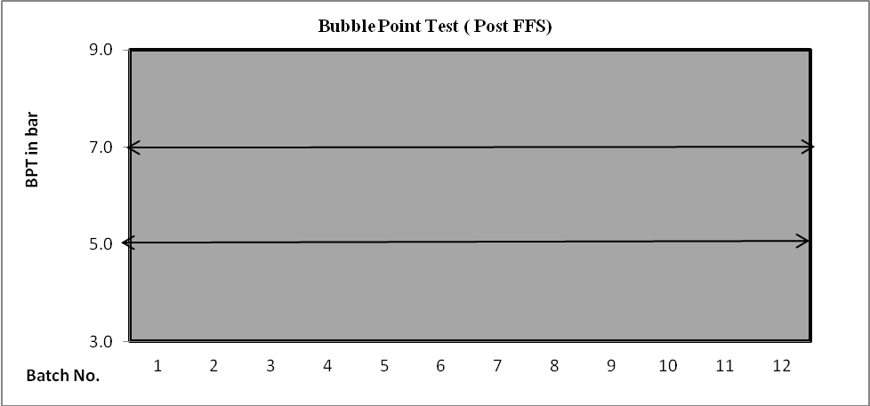

Comments:

- Yield of all critical stages and their trend graph:
Batch No. | Yield after filling | Yield after Sterilization | Yield after Leak testing
- Yield after filling:
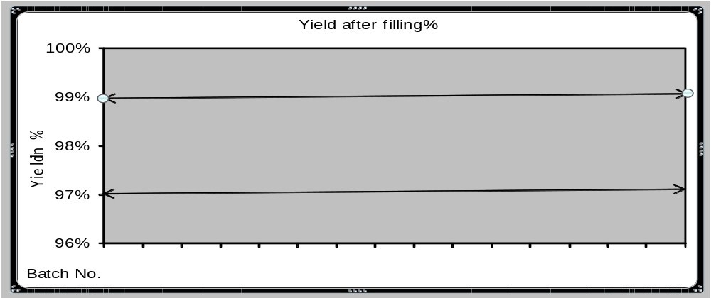
Comments:

- Yield after Sterilizatio:
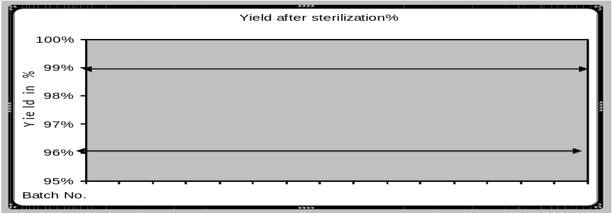
Comments:

- Yield after Leak testing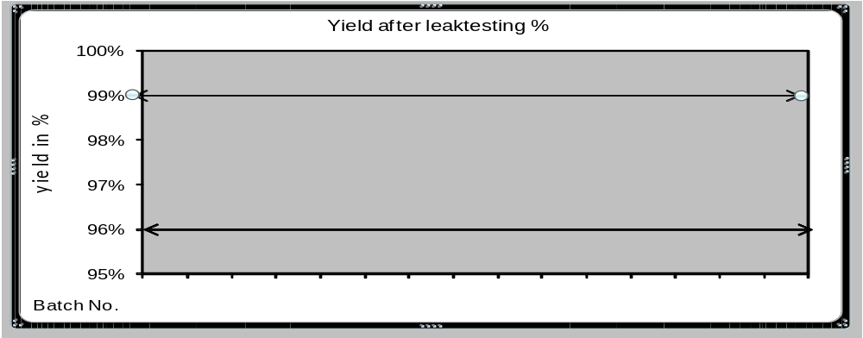:
Comments:

- Final Batch Yield at the end of all critical stages & Analysis report with trend graph:
B. No. | Mfg. Date | Exp. Date |  |  |  | Parameters
B. No. | Mfg. Date | Exp. Date | Extractable volume |  |  | Assay |  | Pack. Yield (%)
 |  |  |  | pH |  |  |  | Pack. Yield (%)
- Extractable volume:
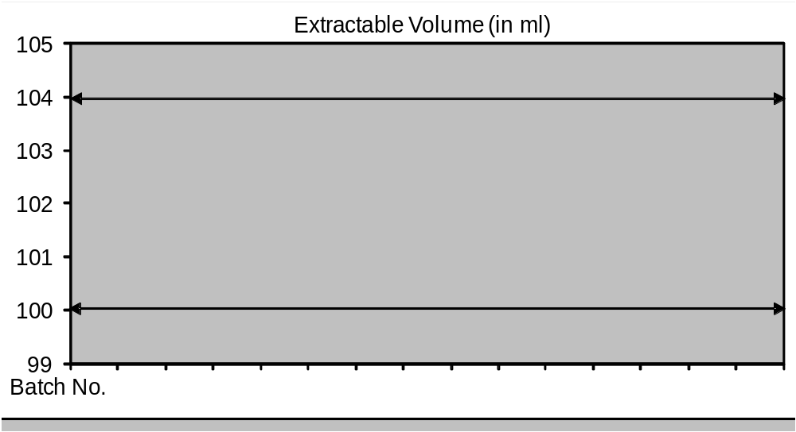
Comments:

- pH:
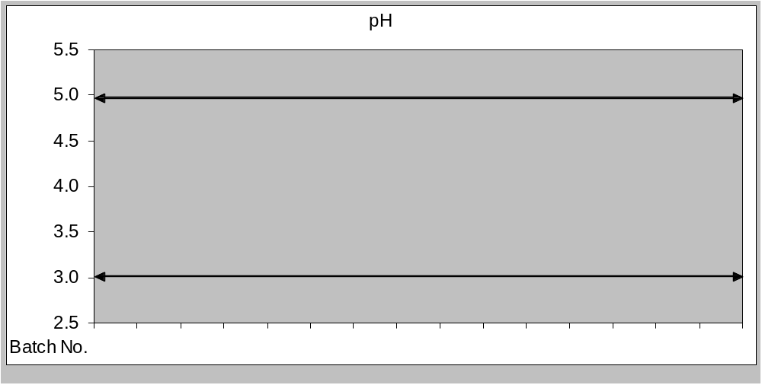
Comments:

- Assay:
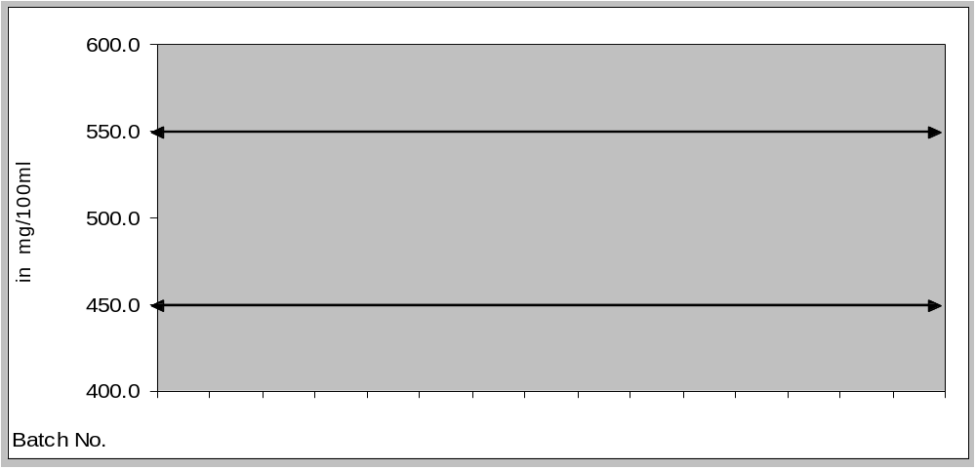
Comments:

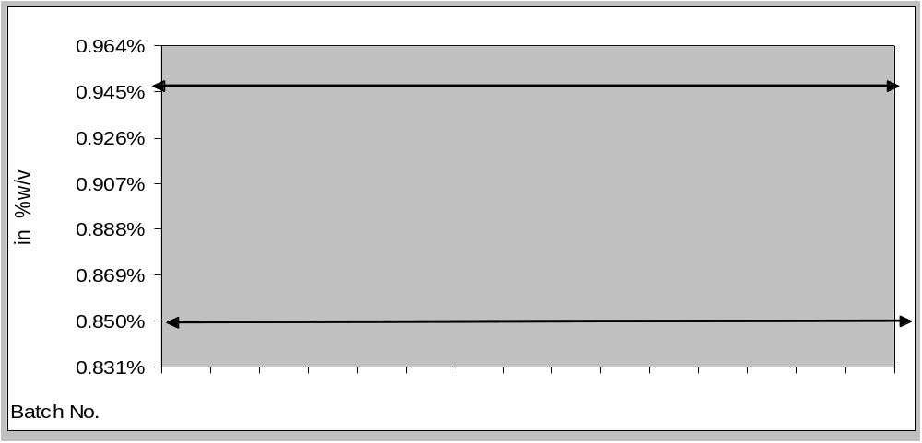

Comments:

- Final pack Yield at the end of all critical stages with trend graph:
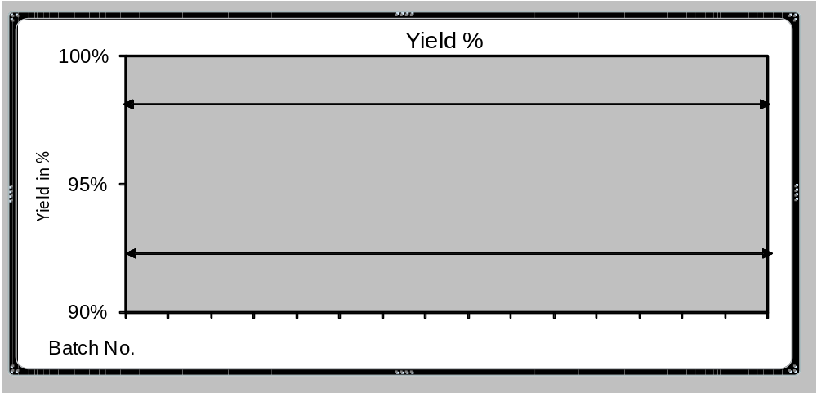
Comments:

- A review of all batches that failed to meet established specification(s) and their investigation. :
- A review of all changes carried out to the processes or analytical methods.
Ref Nos | Pack Related / Regular Change control | Change | Effective from (Batch Nos)
- Out of specifications and laboratory Investigations:
- Process Validation Status:
- Review of Deviation:
- A review of all quality –related returns, complaints and recalls and the investigations performed
at the time.
Batch no | Recd from | Complaint | Status (Genuine/  Non genuine) | Corrective Actions Taken | Status as on date
- Control Sample Review:
- A review of previous APRs of the product and review of any identified delays in CAPAs or
incidence
- A review of the results of the stability monitoring programme and any adverse trends.
- The qualification status of relevant equipment and utilities, e.g. HVAC, Water etc.
- A review of Product Sterilization parameters (duration of process, temperature and pressure)
- A review of any contractual arrangements to ensure that they are up to date.
- Annual Product Report – Summary
Summary and conclusion:

 | Prepared By | Comments / Recommendations By | Approved By
Sign / Date
Department

********end of document*********

